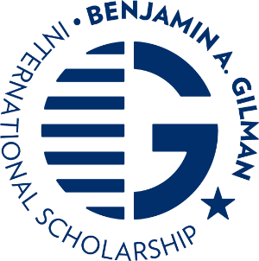
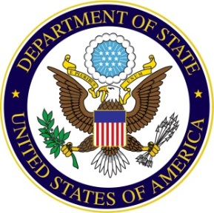

FOR IMMEDIATE RELEASE Contact: ECA Press Office

Date: 00/00/2018 Telephone: 202-632-6445

(College Name) Student (student name) awarded
U.S. Department of State’s Benjamin A. Gilman International Scholarship TO study abroad

Month Day, Year – The U.S. Department of State is pleased to announce that (Student’s name), from (institution) is one of 835 American undergraduate students from 310 colleges and universities across the United States selected to receive the prestigious Benjamin A. Gilman International Scholarship to study or intern abroad during the fall of 2018 or the 2018-2019 academic year. The complete list of students who have been selected to receive Gilman Scholarships this term, including students’ home state, university, and host country, is available on the website: gilmanscholarship.org.
Gilman Scholars receive up to $5,000 to apply towards their study abroad or internship program costs with additional funding available for the study of a critical language overseas. The Gilman Scholarship supports American undergraduate students of limited financial means to study or intern abroad and, since 2001, has enabled more than 25,000 outstanding Americans of diverse backgrounds to engage in a meaningful educational experience abroad. The program has successfully broadened U.S. participation in study abroad, while emphasizing countries and regions where fewer Americans traditionally study.
The late Congressman Gilman, for whom the scholarship is named, served in the House of Representatives for 30 years and chaired the House Foreign Relations Committee. When honored with the Secretary of State’s Distinguished Service Medal in 2002, he commented, “Living and learning in a vastly different environment of another nation not only exposes our students to alternate views, but adds an enriching social and cultural experience. It also provides our students with the opportunity to return home with a deeper understanding of their place in the world, encouraging them to be a contributor, rather than a spectator in the international community.”
The Gilman Program is sponsored by the U.S. Department of State’s Bureau of Educational and Cultural Affairs and is supported in its implementation by the Institute of International Education (IIE).

***********

The U.S. Department of State, Bureau of Educational and Cultural Affairs’ (ECA) mission is to build relations between the people of the United States and the people of other countries through academic, cultural, sports, professional and private exchanges, as well as public-private partnerships and mentoring programs. These exchange programs improve foreign relations and strengthen the national security of the United States. ECA programs, funding, and other activities encourage the involvement of American and international participants from traditionally underrepresented groups, including women, racial and ethnic minorities, and people with disabilities. Artists, educators, athletes, students, youth and rising leaders in the United States and more than 160 countries around the globe participate in academic, cultural, sports, and professional exchanges. For more information about ECA programs, initiatives, and achievements, visit eca.state.gov.

The Institute of International Education (http://www.iie.org/) works with policymakers, educators and employers across the globe to prepare students and professionals for the global workforce and equip them to solve the increasingly complex challenges facing our interconnected world. An independent, not-for-profit organization founded in 1919, IIE has a network of 18 offices and affiliates worldwide, and over 1,300 member institutions.

